JSBSim Documentation (QT Creator)

Setting Up The System for JSBSim:
- Install Ubuntu latest addition on a separate drive.
- Connect the system to Internet. Goto Software and Update application, in Ubuntu Software tab set “Download from :” to “Server of United States” using a drop down menu.
- Open a terminal and run “sudo apt-get update”, than “sudo apt-get upgrade”. They will update the package list as per archives on the server.
- Open Ubuntu Software Center and search for “Synaptic”. From results select and install “Synaptic Package Manager”. This utility helps install different packages and also takes care of package dependencies.
- We shall use Synaptic Package Manager to install new packages. (Note: since the base utility to install a package is “apt-get” command, so at a time only one of its instance can be run, i.e. you can either install a package from Synaptic or Software Center or by using apt-get in a terminal at a same time.
- Open Synaptic Package Manager. Click the reload button, it will update the Synaptic's package database. In the search box ,write the name of the package you want to install. Synaptic will filter the packages for you. Chose the suitable package by clicking on it. It will ask you to mark that package for installation. When you Mark it for installation, a dialog box will show up telling you which packages will be installed, updated, or deleted, based on the compatibility and dependencies of the package you have marked. Click OK, if you feel so and then click the Apply button. Synaptic Package Manager will do the rest.
- Here is the list of the packages you need to install.
qtcreator
qtcreator-dev
qtcreator-doc
qt5-doc
g++
libstdc++6
libstdc++-4.8-dev
gcc
gcc-4.9-base
libgdal1-dev
libgdal-doc
libgdal-dev
autotools-dev
autoconf
automake
libalut0
libalut-dev
freeglut3
freeglut3-dev
- Make sure that your graphic drivers are correctly installed and configured, for that you would have to consult Internet, depending upon your graphics card.

Generating .pro file and Opening JSBSim in QT Creator:
- To generate .pro file, we have to refer to QT Creator documentation “The Art of Building Qt Applications”.
- Open console and change current directory to JSBSim folder. Type “qmake -project”, it will generate the project file. Close the QT Creator and open the JSBSim from the generated project file.
- Check the .pro file, it would have included all the paths of source and header files automatically.
- Build it to check for errors.

Running JSBSim in QT:
- In order to run the project we have o provide it the respective arguments.
- To do that, go to Projects Tab in left side pan of QT Creator when JSBSim project is open.
- In Build & Run settings select RUN.
- Provide it the Executable File (JSBSim-1.0) i.e. the object file generated when the project is build. (All object files are present in Debug Folder)
- in Arguments type as required, for example, if you want the JSBSim to run for T37 aircraft in real time you will type “--script=scripts/T37 –realtime”.
- Set Working Directory to Debug Folder.
- For JSBSim to get the scripts and other files successfully we have to edit the the root directory in JSBSim.cpp to relative path, the command to achieve this is “ string RootDir = "../"; ”.
- Now Run the project, it should run successfully.
- (Note: For above procedure to work the Debug Folder must be inside JSBSim-1.0 Directory, which is generally not true, so you have to relocate the Debug Folder inside the parent directory)

Adding a Class:
- Open JSBSim in QT Creator IDE, it will distribute it in the form of a project with source and header files.
- Expand the project, right click on the “models” folder and select “Add New”.
- A dialog box will open, select “C++” in Files and Classes box, check C++ Class and click chose as shown in figure 1.
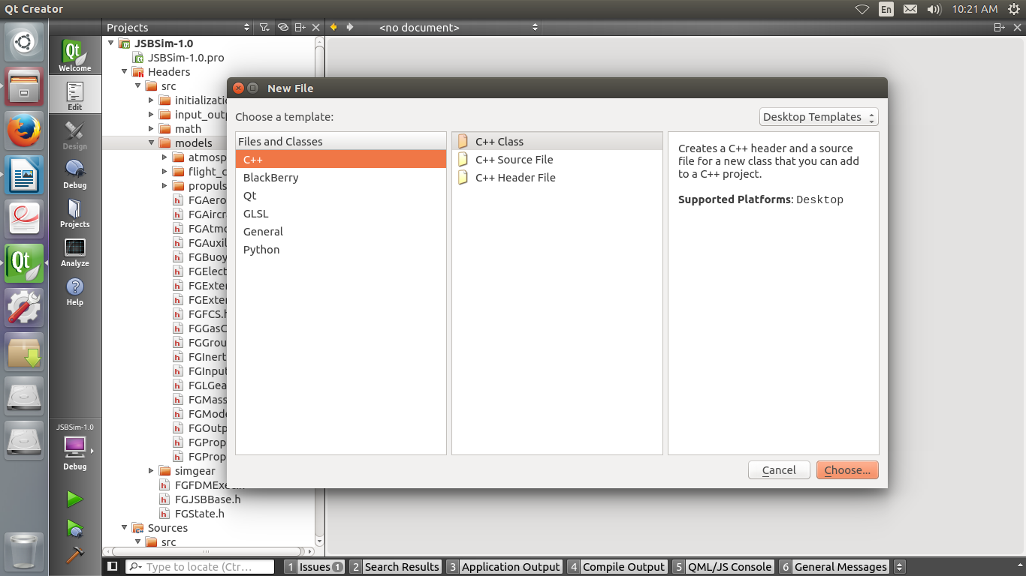Figure 1 : Adding New Class
- In next dialog enter the class details. In class name enter the name of class, in base class enter “FGModel” , ignore type information. Header file and source file names will be filled automatically, but still you can edit them for your own convenience. For example if electrical system is required to be added than the sample class information would be
Class name : FGElectricalSystem
Base class: FGModel
Type information: None
Header file: FGElectricalSystem.h
Source file: FGElectricalSystem.cpp
Path: /Document/JSBSim-1.0/src/models........

- After filling class information click next and than click finish.
- This will automatically add the said class' header and source file at appropriate location, and will include the file path in the .pro file.
- Header and source file generated by above method will be filled with some generic class formation. Clear everything from both file.
- Copy content of any other model class header and source file and paste it in respective files of the new class. This will help us follow the convention used in JSBSim code.
- Edit the header and the source file as per the new system requirement, but following the same convention. Note: Comment out the declaration and definition of Bind and Unbind methods at the moment.
- After editing, compile the project, so that there are no issues so far.
- Now to integrate this class into existing framework, we have to add its reference and instance at different locations. It is done by following the convention used for all other model classes.
- We have instantiate, declare and define our class in FGModel and FGFDMExec classes. It is done by finding the traces of instantiation, declaration and definition of other model classes and adding the same for our new class.
- Finally compile the project again to check for errors.

Modifying JSBSim for IOS Commands:
In larger simulation networks starting and stopping JSBSim is done via an external application called Instructor Operating Station (IOS). Applications can communicate with each other in number of different ways. We will use DDS (Data Distribution Service) to achieve the purpose which I'll explain later. Before DDS integration we will make certain additions to the code to enable to to run via IOS.
- In JSBSim.cpp declare a variable with bool type “SocketFlag” and initialize it to false.
- Than inside real_main() in parsing block add the following statements ;
while (SocketFlag == true)
{
ScriptName = "scripts/T37";

break;
}

This will ensure that program does not start until SocketFlag is true, further script file is hard coded because at a time we will only simulate one aircraft.
- Now to make this work, SocketFlag must be changed externally. This will be done through a command line switch. Lets name this switch “--scoket”. In JSBSim.cpp under function “options()” add the following sequence following the convention.
else if (keyword == "--socket") {
SocketFlag = true;
}
This will enable us to make SocketFlag true externally.
- For testing purpose, goto Projects tab in QT, than in run set the arguments to “--socket” in place of “--script/scripts”.
- Build and run to check.
- In JSBSim.cpp there is a function called “PrintHelp”. You can also add help feature for your newly added flag as per convention.

Integration of Data Distribution Service (DDS):
In larger simulation networks, several different applications need to communicate with each other, some on the same nodes and some on different. There are different types of network architectures which can be followed such as network centric, data centric etc. DDS is a data centric architecture, where data is key access feature not the place of origin. We will implement DDS through OpenSplice DDS utility which is an open source utility. In DDS there is global space to which multiple nodes can connect. Each node has the ability to write and read data from the this global space. Nodes connect with each other through pub sub theory. Each node has a publisher which writes it output data to the global space, and a subscriber which reads data from the global space. First of all global space is creted which we will call DDS Domain. Then topics are added. Topics correspond to applications or the nodes. Than publisher and subscriber are created along with readers and writers. These are connected with the topics. The specific steps required to bring upon this revolution in JSBSim code are listed below.
- Download and install OpenSplice DDS in HDE package.
- After this we have to set the environment variables for DDS. To do this goto the parent folder of DDS. For my case it was “/home/suhayl/HDE/x86_64.linux2.6/”. While in this directory run following command “. ./release.com”. It will set all the environment variables for you automatically.
- Every application developer will generate an IDL file, for the type and information of data he is going to publish to the DDS Domain. Sample IDL file, which in this case is for FDM, is shown below;

#FDM.idl
module FDM
{
struct fdmdata
{
long ID; // User ID
double Latitude;
double Longitude;
double Altitude;
double Velocity;
};
#pragma keylist fdmdata ID
};

- This IDL file will be used to generate different header and source files, which will be added to JSBSim project for DDS to work. These files act as translators or interpretors. These can be generated by a single command. For this purpose goto directory containing IDL files and write the following command.
“…............. $ idlpp -S -l cpp FDM.idl -d FDMData”
Here idlpp is the keyword, -S is a switch, -l is for language, FDM.idl is the filename with extension, -d is a switch for creating a new folder for files which are to be generated while FDMData is the folder name.
- Now we come to the JSBSim code, here we have to add several files and paths, and have to make lot of changes. Make a folder with name DDSInterface inside src folder of JSBSim project.
- Goto examples in DDS folder than helloword, c++ and than src. There you will find files named “CheckStatus” and “DDSEntitManager” in .cpp and .h. Copy these files to DDSInterface folder.
- Also Copy the files generated previously with IDL file to the DDSInterface folder.
- Change the filenmae of “DDSEntitManager” to “DDSInterface”. This is just for convention.
- Open the JSBSim project in QT.
- Add the “include/dcps/C++/SACPP” , “include/sys”, “include” (FROM DDS Directory) and src/DDSInterafce (FROM JSBSIM Directory) in include path block of .pro file.
- Include the newly copied header and source files in header and source files blocks.
- Finally at the end of .pro file use LIBS keyword to add DDS libraries to the code. These libraries are present in lib folder inside DDS directory. All these libraries need to be added. Following line gives a sample way of adding them “LIBS += -L/home/suhayl/HDE/ x86_64.linux2.6/lib/ -lcmxml -lcmjni …..........”. In this sample you can see that file name of library is edited, where “lib” is replced by “l” only.

Editing DDSInterface file according to our needs:
- Open JSBSim project and goto DDSInterface.h file.
- Since this copy of file was copied from HelloWorld project, so we will use the convention and configure it according to our own needs.
- At the top of the file, change the definitions from DDSEntitymanager to DDSInterfae.
- In includes add “FDMExec.h”, “FDMcps_impl.h”, and “string.h”.
- After include namespaces as given below;
using namespace DDS;
using namespace FDM;
namespace JSBSim {
In this way whole class will be encapsulated within JSBSim namespace.
- Than change the class name to DDSInterface and inherit the class from FGModel that is the model class of JSBSim project. This is done as follows
class DDSInterface: public FGModel
- Declare constructor DDSInterface(FDMExec*) and another without arrguments DDSInterface().
- Since it is child of Model class, so it will carry all the common functions of other model classes, such as InitModel(bool holding), Run() etc.
- Further follow the approach as already done in the code. In Topic_var create fdmdatatopic, than its writer. Similarly when other topics will be added there readers would be added.
- NOTE: Better option is to copy DDSInterface files from previous project.
- Its implementation is however important and simple. Just like other model classes, edit FDMEexc in header and source file to implement it.
- You have to copy startDomain.sh file to Debug folder of JSBSim project. Make it executable using chmod. And run it in the constructor of DDSInterface with command system(“./startDomain.sh)

